**Name: Session:**

**Programming II**

**Lab Exercise 4.14.2020**

In this exercise, we will build an MP3 Player. We will build this in 3 stages demonstrating incremental product development. Version 1.0 will allow us to add songs to our playlist as well as having some basic control features. In version 2.0, we will create a Play function that is called by the btnPlay_Click event handler. This will allow flexibility in that we will then be able to start the playlist by calling Play from some other function. Finally version 3.0 will add the capability to save and load playlists as simple text files. I have provided starter code for each of these versions.

**Version 1.0**

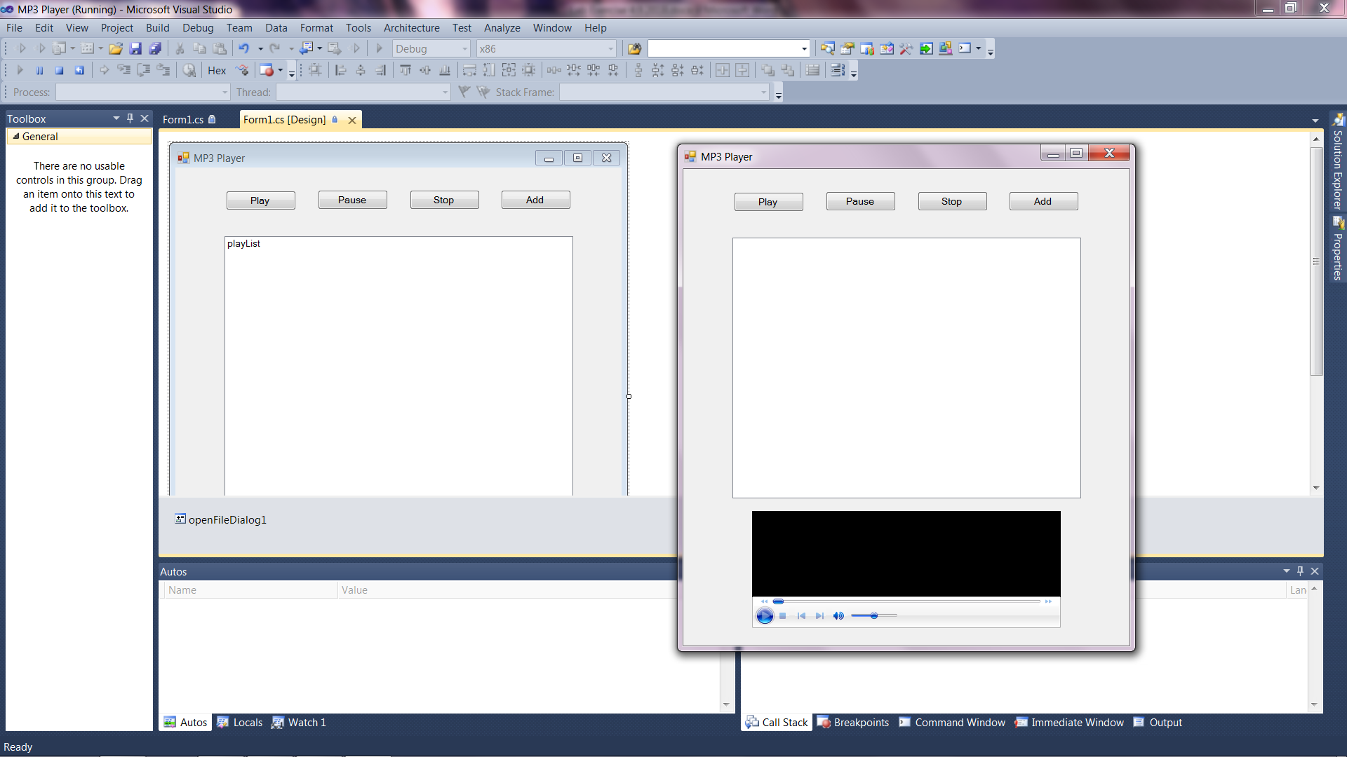

1. Add the following code to the btnPlay_Click event.

//Create a PlayList object

var myPlayList = mediaPlayer.playlistCollection.newPlaylist("MyPlayList");

//Add each item in the playList ListBox to the PlayList object

foreach (string media in playList.Items)

{

var mediaItem = mediaPlayer.newMedia(media);

myPlayList.appendItem(mediaItem);

}

//Start playing the playlist

mediaPlayer.currentPlaylist = myPlayList;

1. Add the following code to the btnPause_Click event.

mediaPlayer.Ctlcontrols.pause();

1. Add the following code to the btnStop_Click event.

mediaPlayer.Ctlcontrols.stop();

1. Add the following code to the btnAdd_Click event.

DialogResult dr;

dr = openFileDialog1.ShowDialog();

if (dr == System.Windows.Forms.DialogResult.OK)

{

foreach (string track in openFileDialog1.FileNames)

playList.Items.Add(track);

}

1. Add the following code to the playList_SelectedIndexChanged event.

mediaPlayer.Ctlcontrols.stop();

mediaPlayer.URL = playList.SelectedItem.ToString();

1. Now test your program to see if it works and debug as necessary.

**Version 2.0**

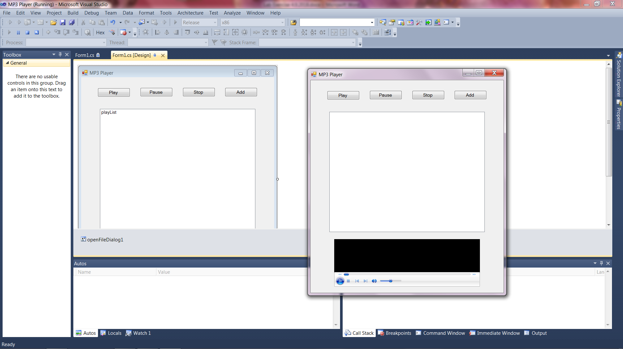

1. Add a play function to your form code.

private void play()

{

//Create a PlayList object

var myPlayList = mediaPlayer.playlistCollection.newPlaylist("MyPlayList");

//Add each item in the playList ListBox to the PlayList object

foreach (string media in playList.Items)

{

var mediaItem = mediaPlayer.newMedia(media);

myPlayList.appendItem(mediaItem);

}

//Start playing the playlist

mediaPlayer.currentPlaylist = myPlayList;

}

1. Add a call to the play function to the btnPlay_Click event.

play();

1. The rest of your code should be unchanged.
2. Now test your program to make sure it works.

**Version 3.0**

In version 3.0, we will add a menu that will allow you to load and save playlists as well as exit the program. We will also have an About menu item which will open a second for to provide information about the software.

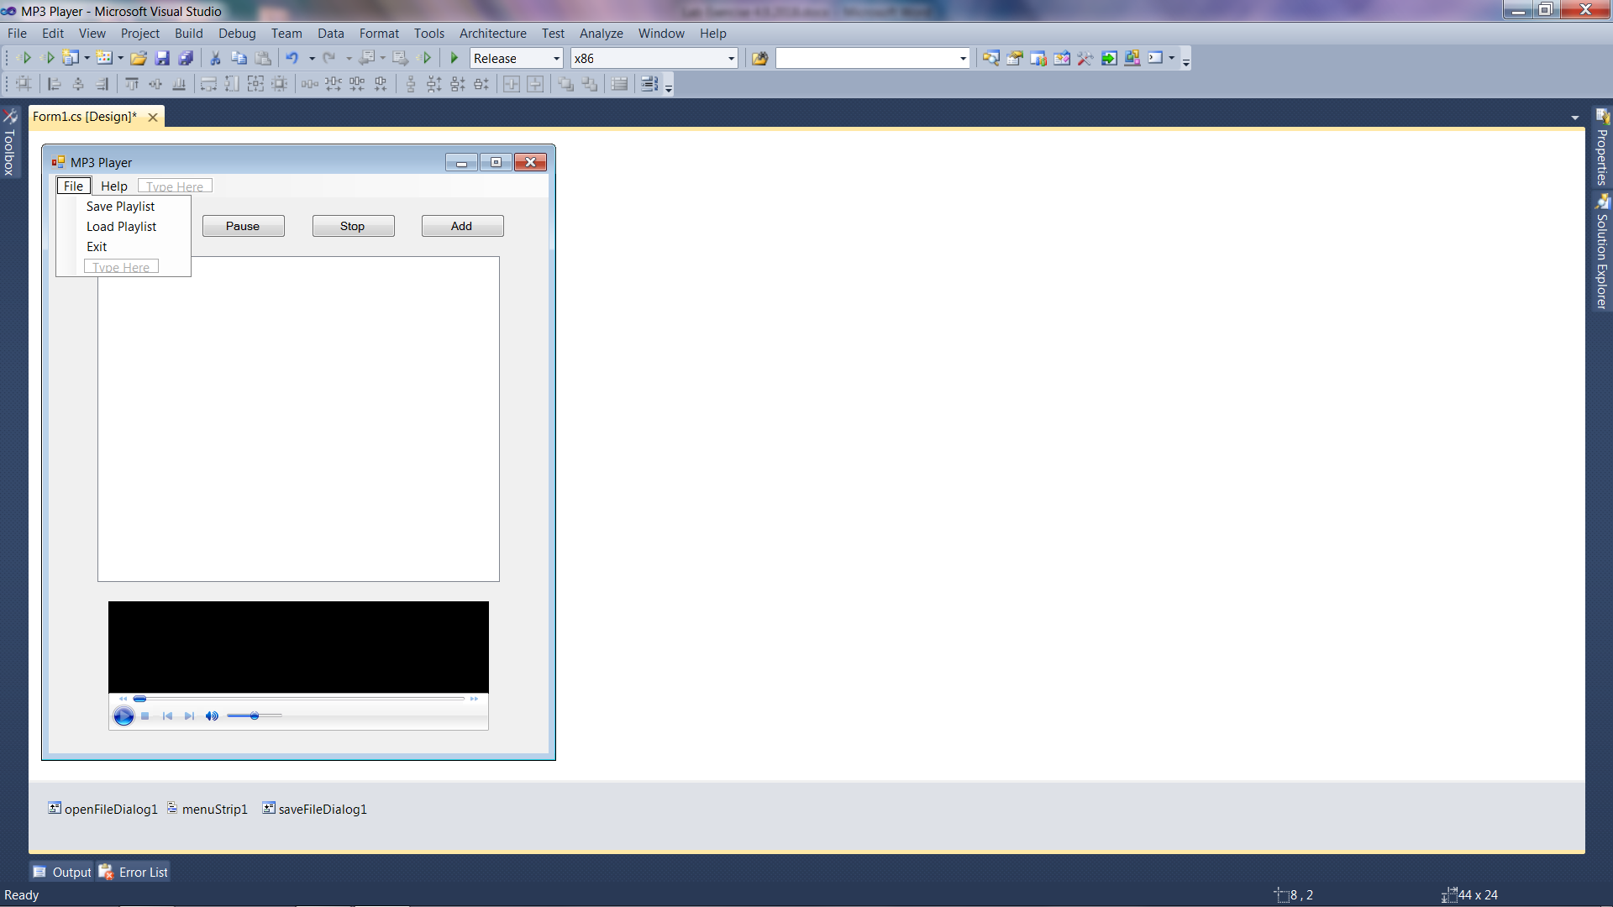 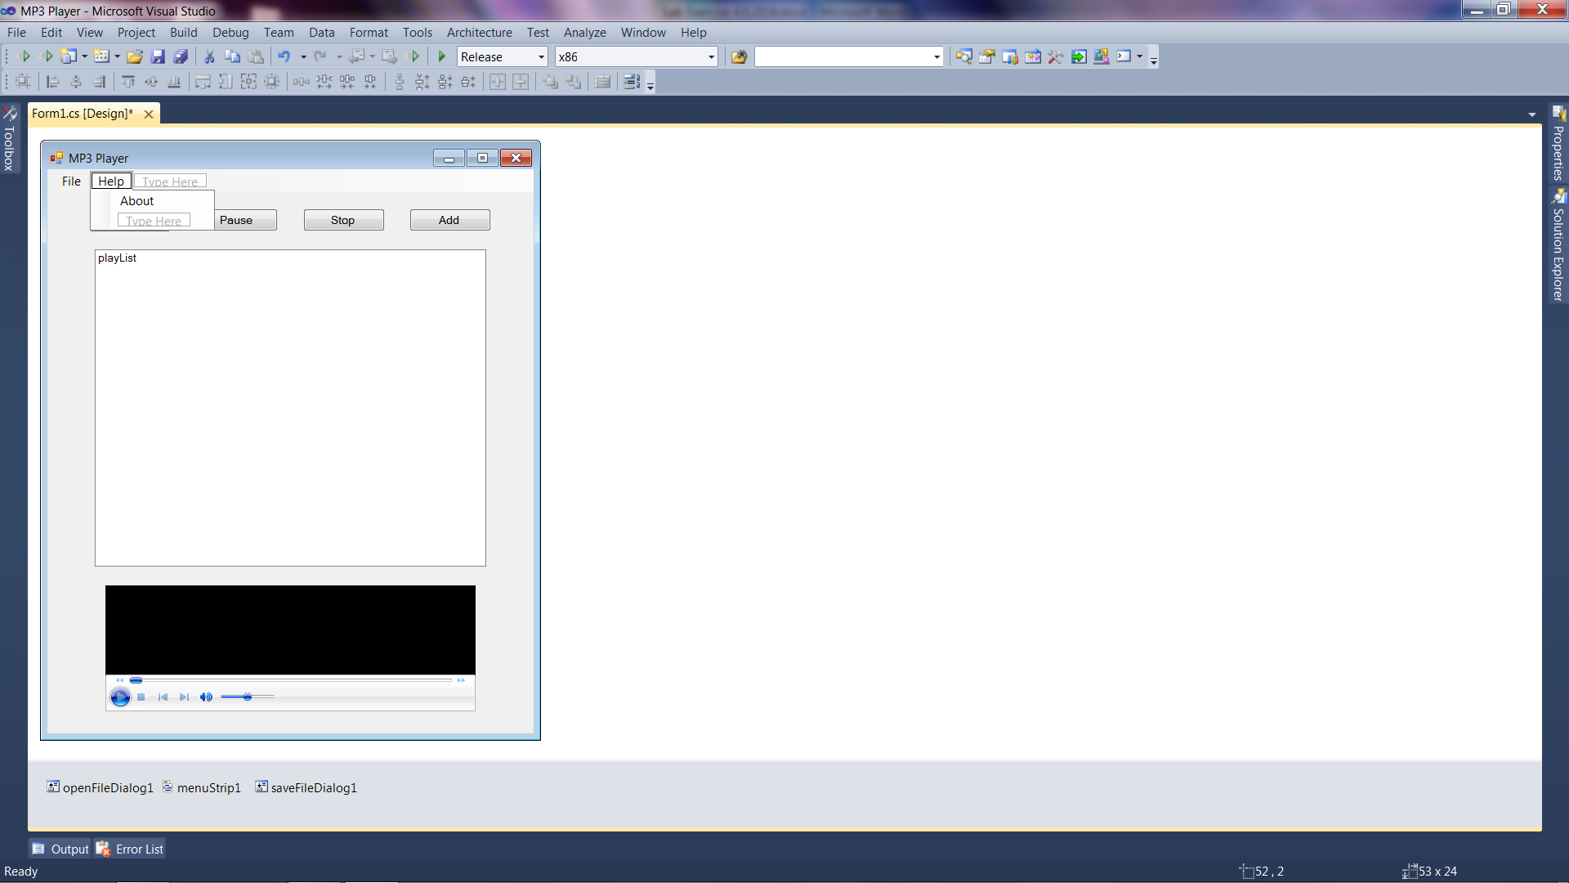

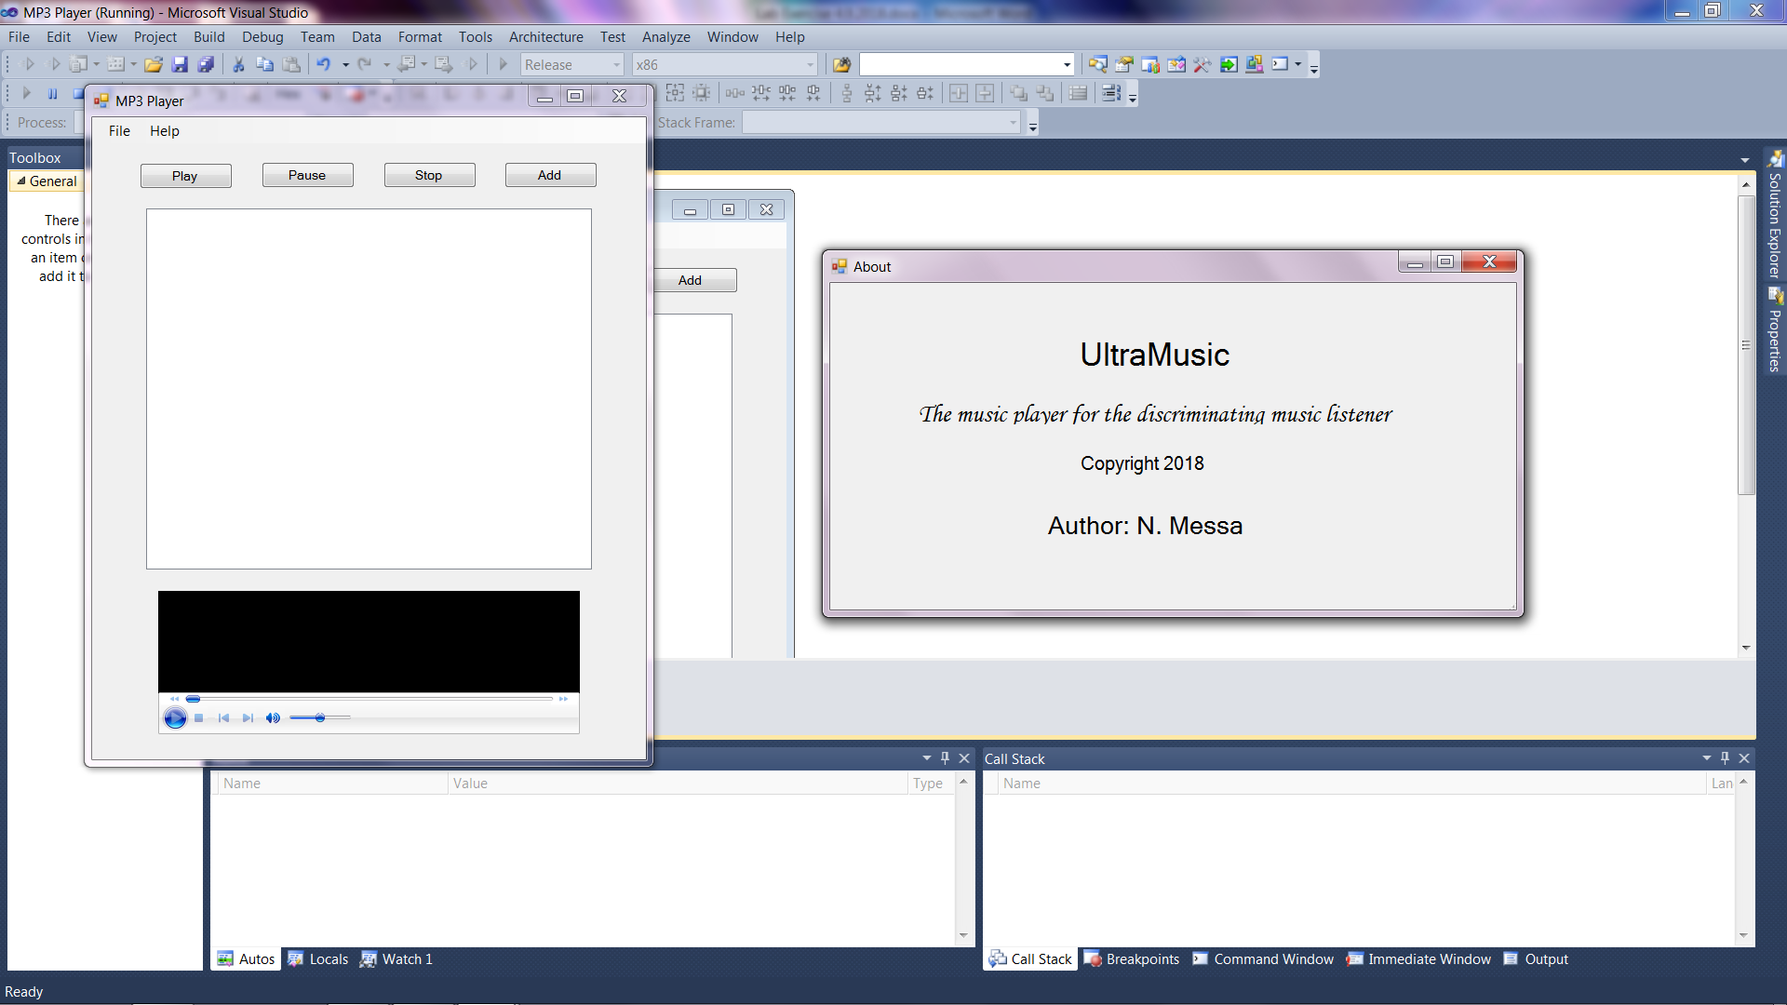

1. Add a MenuStrip to your form and configure it per the figures above.
2. Add a new Windows Form to your project and make sure it is named About.cs

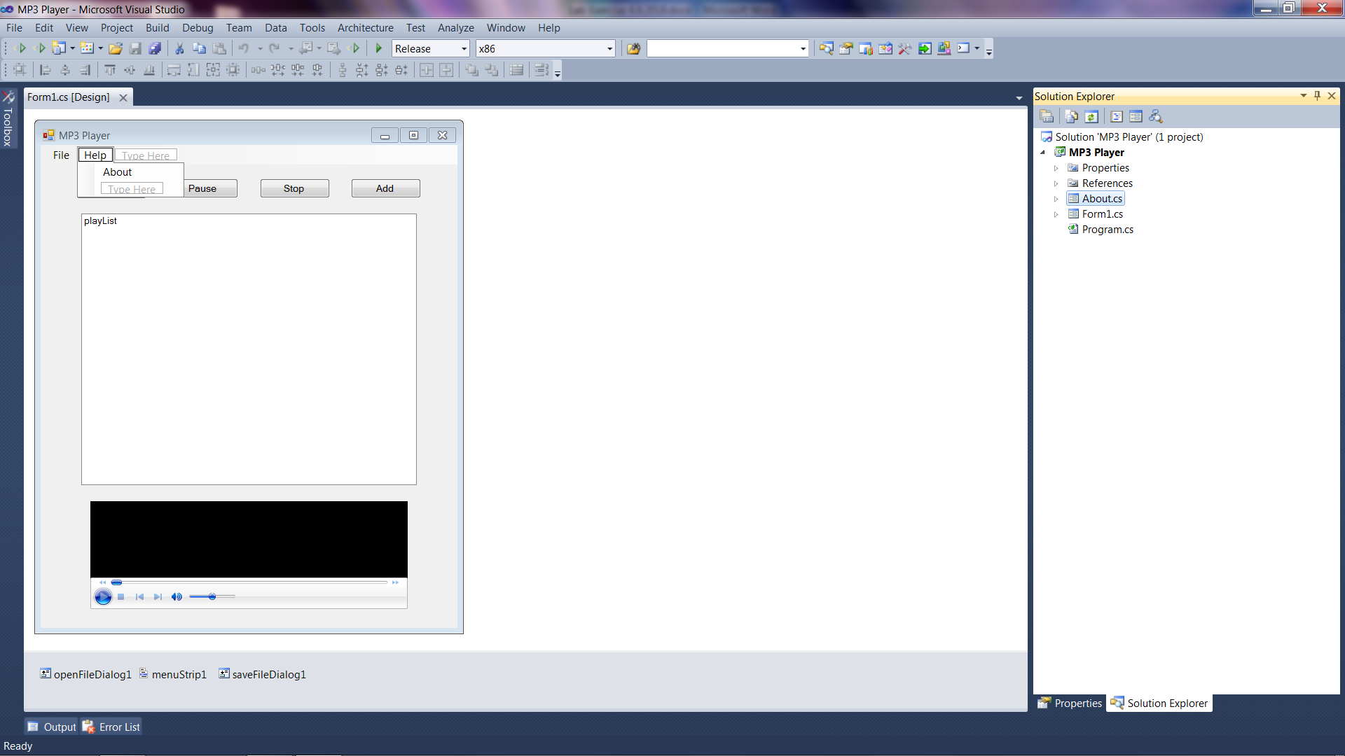

1. Now we need to program the MenuStrip events.
2. Add the following code to the savePlaylistToolStripMenuItem_Click event

DialogResult dr;

dr = saveFileDialog1.ShowDialog();

string sfdName = saveFileDialog1.FileName;

string track;

string tracks = "";

if (dr == System.Windows.Forms.DialogResult.OK)

{

for (int i = 0; i < playList.Items.Count; i++)

{

track = playList.Items[i].ToString();

tracks += track + Environment.NewLine;

}

System.IO.File.WriteAllText(sfdName, tracks);

}

1. Add the following code to the loadPlaylistToolStripMenuItem_Click event

DialogResult dr;

dr = openFileDialog1.ShowDialog();

string ofdName = openFileDialog1.FileName;

if (dr == System.Windows.Forms.DialogResult.OK)

{

var tracks = System.IO.File.ReadLines(ofdName);

foreach (var track in tracks)

playList.Items.Add(track);

}

1. Add the following code to the aboutToolStripMenuItem_Click event

About a = new About();

a.ShowDialog();

1. Finally, customize the About form design to make it your own.
2. Test your final product and make sure it works.
3. **Print out a screenshot of your running program (version 3.0) including the About form, attach it to this sheet and turn in.**